**Character and Set Design Couse Work 1 Report**

**Introduction**

In this report I will be detail my entire design and modelling process for the robotic athlete. This will include the design pipeline, working and adapting from inspiration, the modelling techniques used, and justification to sing a wide variety of techniques that Maya has to offer.

**Pre-Production and Planning**

**Techniques and Surfaces**

2-3 pages

**Body**

* Imported blueprint sketched as image planes in Maya, and scaled to all be the same size

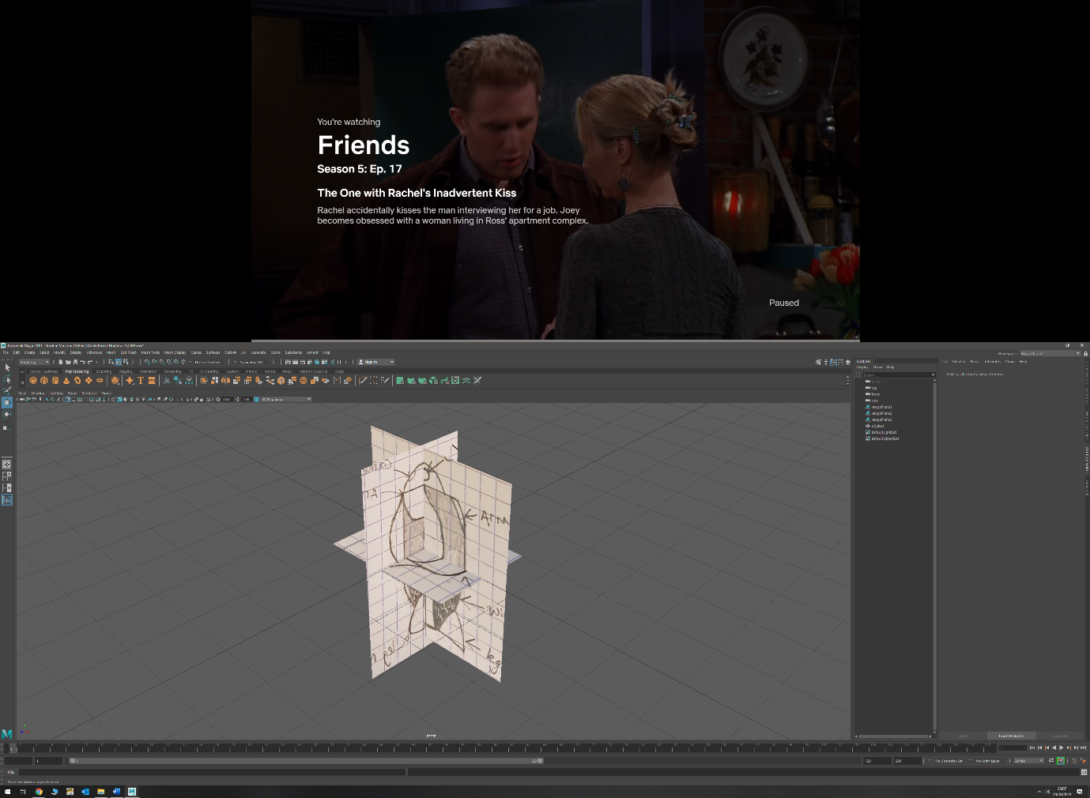

* Added edge loops to a cube after manipulating size to match sketches

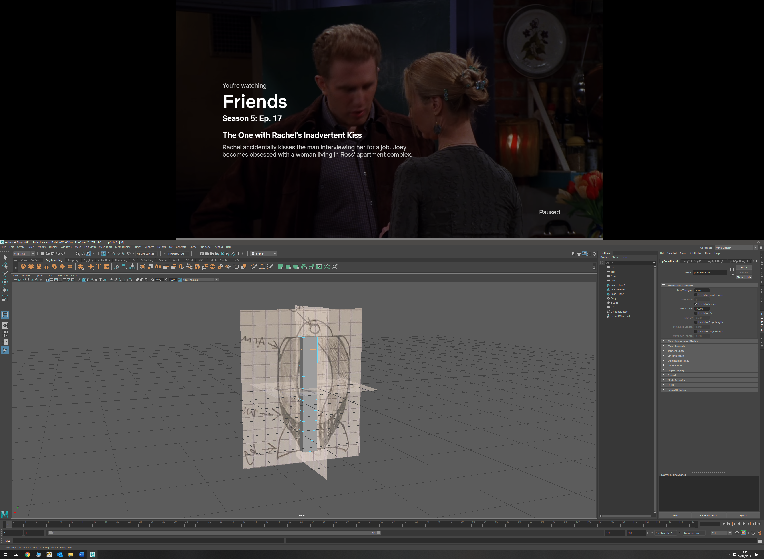

* Manipulated new edges in order to fit body to match blueprints by moving positions in the different orthographic views

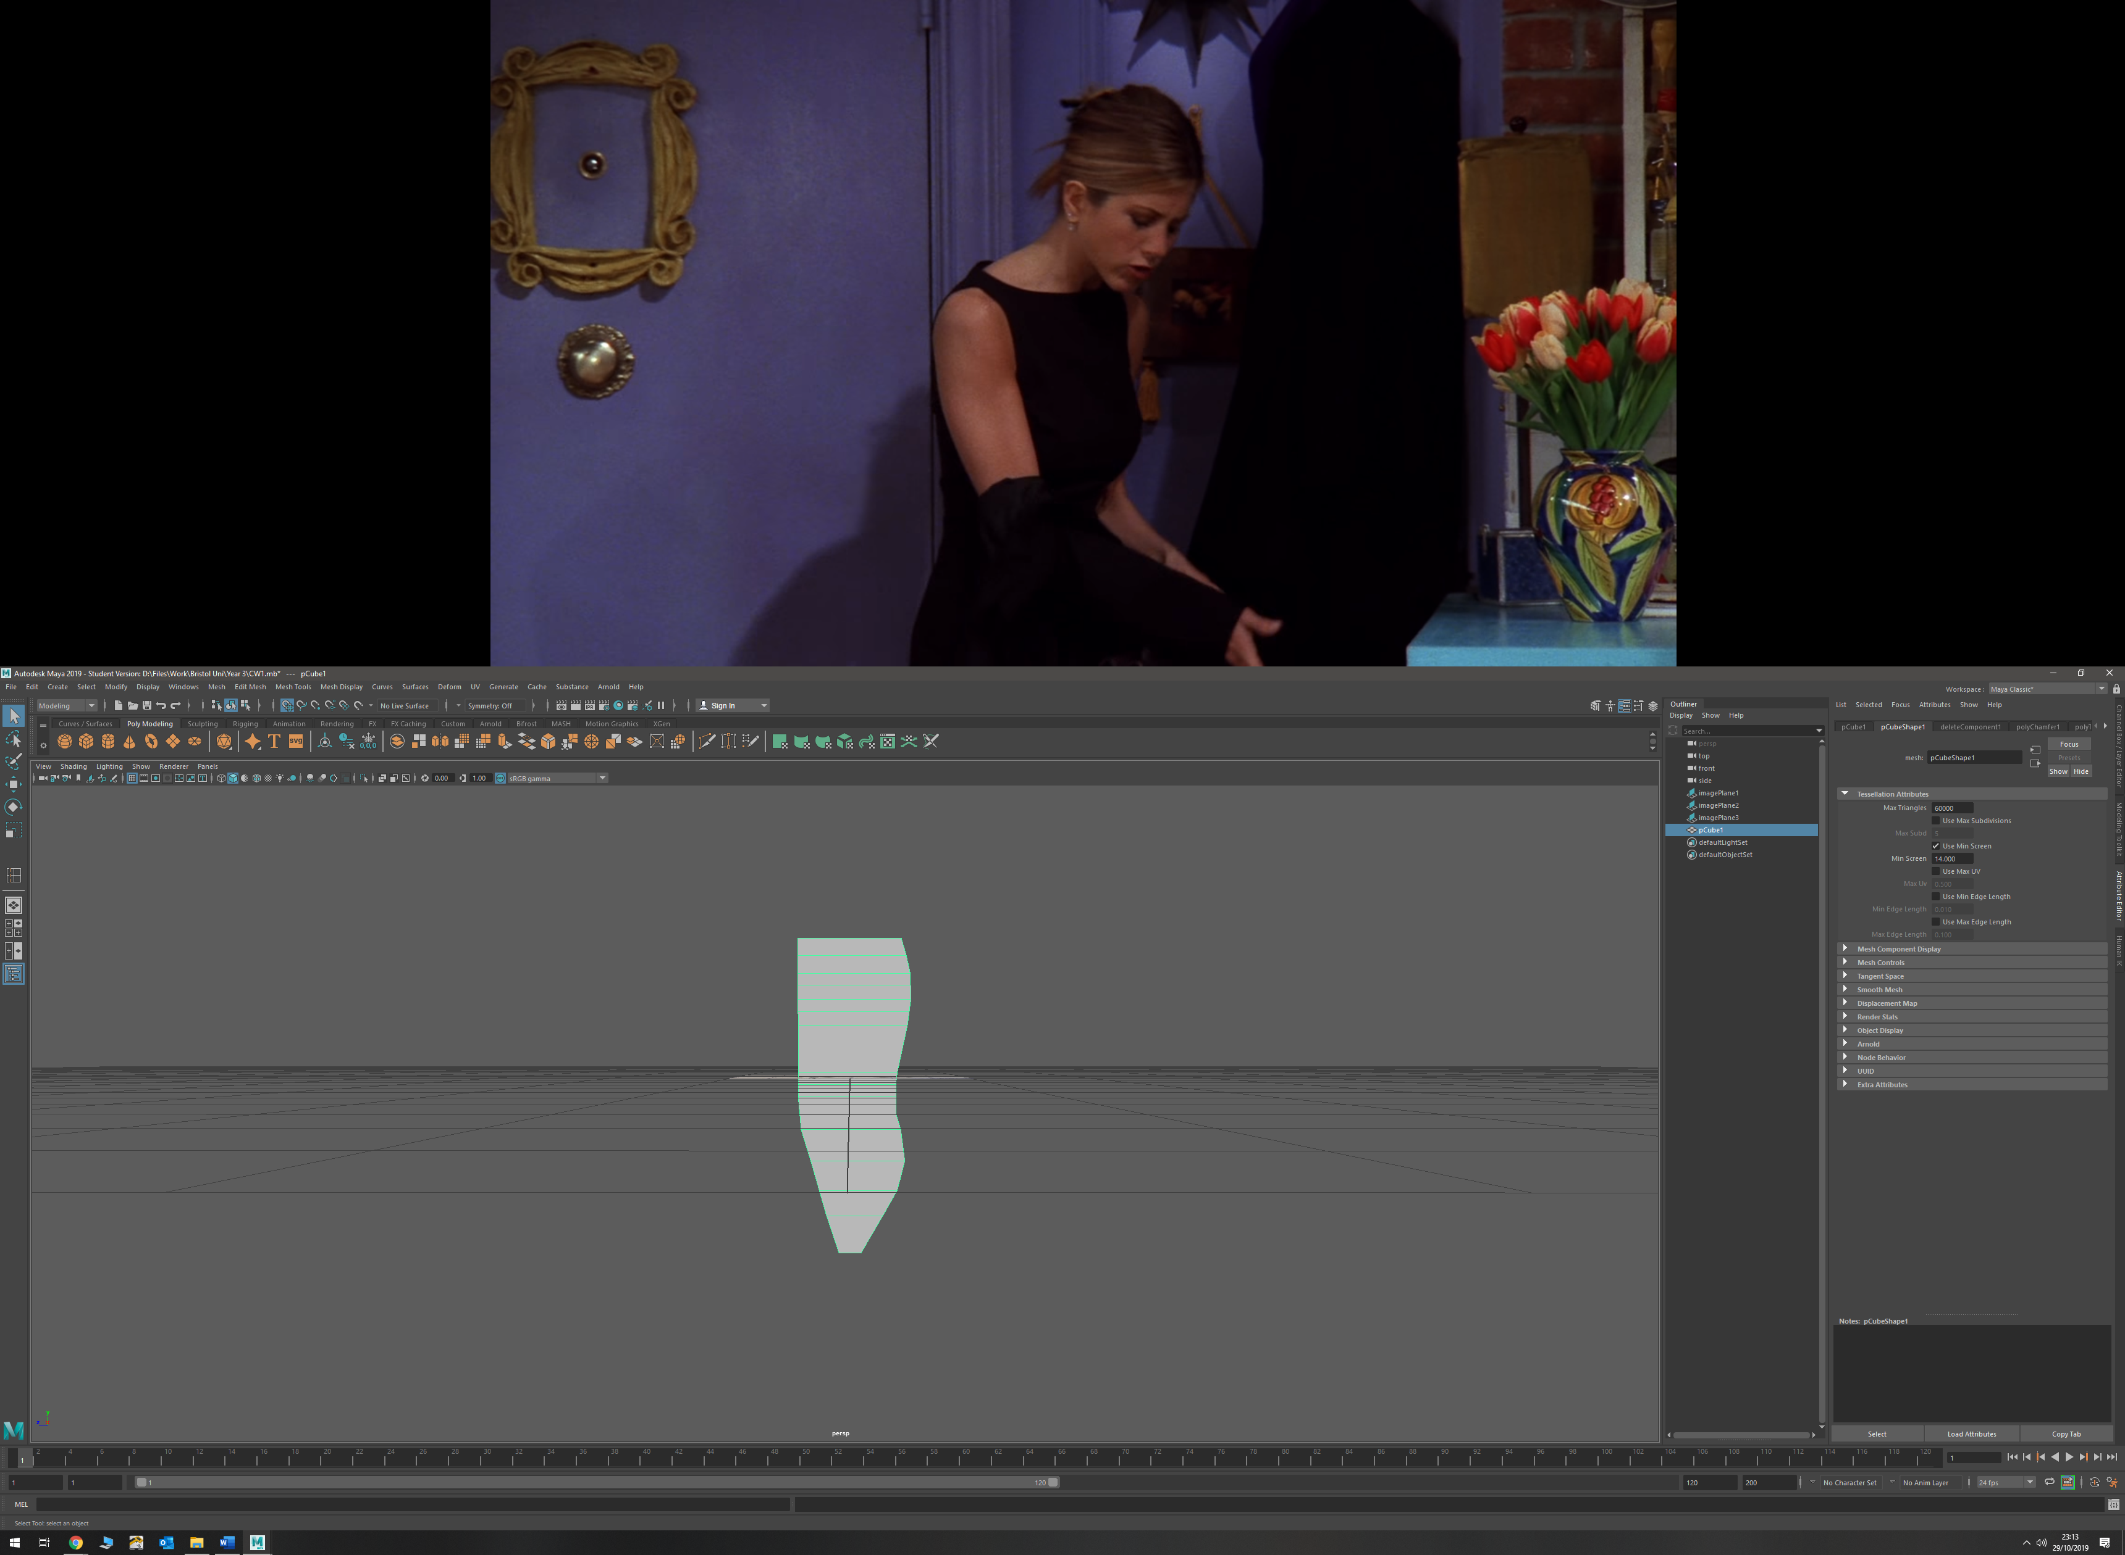

* Bevelled edges using bevel tool to get correct shape. Changed number of bevels to 4

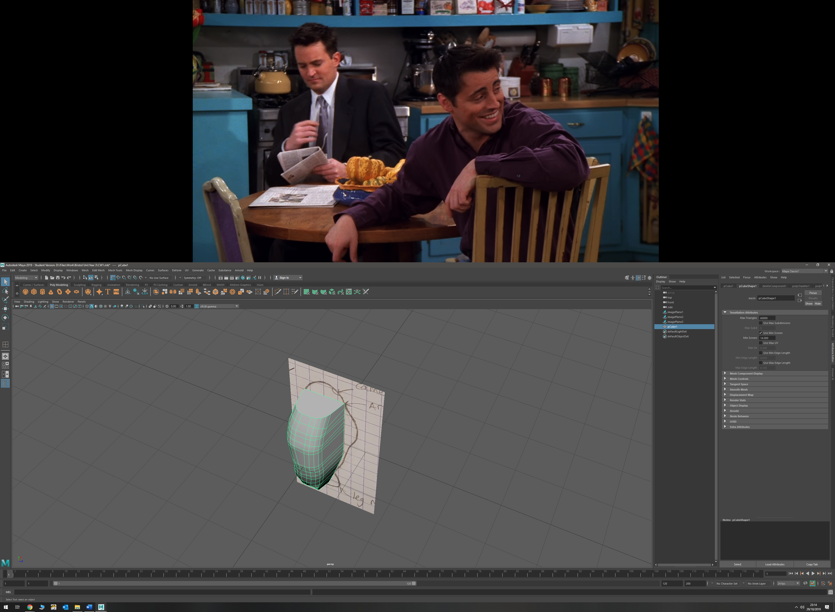

* Bevelled 2 vertices near bottom of model in order to make shape more coherent

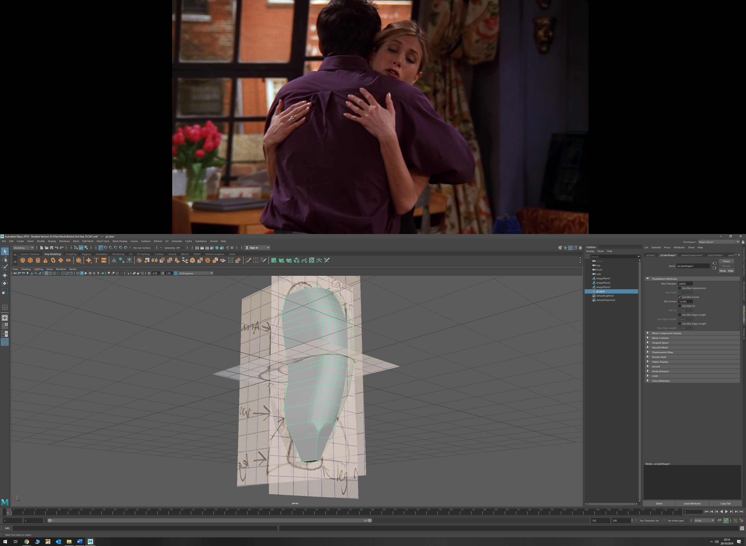

* Drew curve around leg mount to get shape

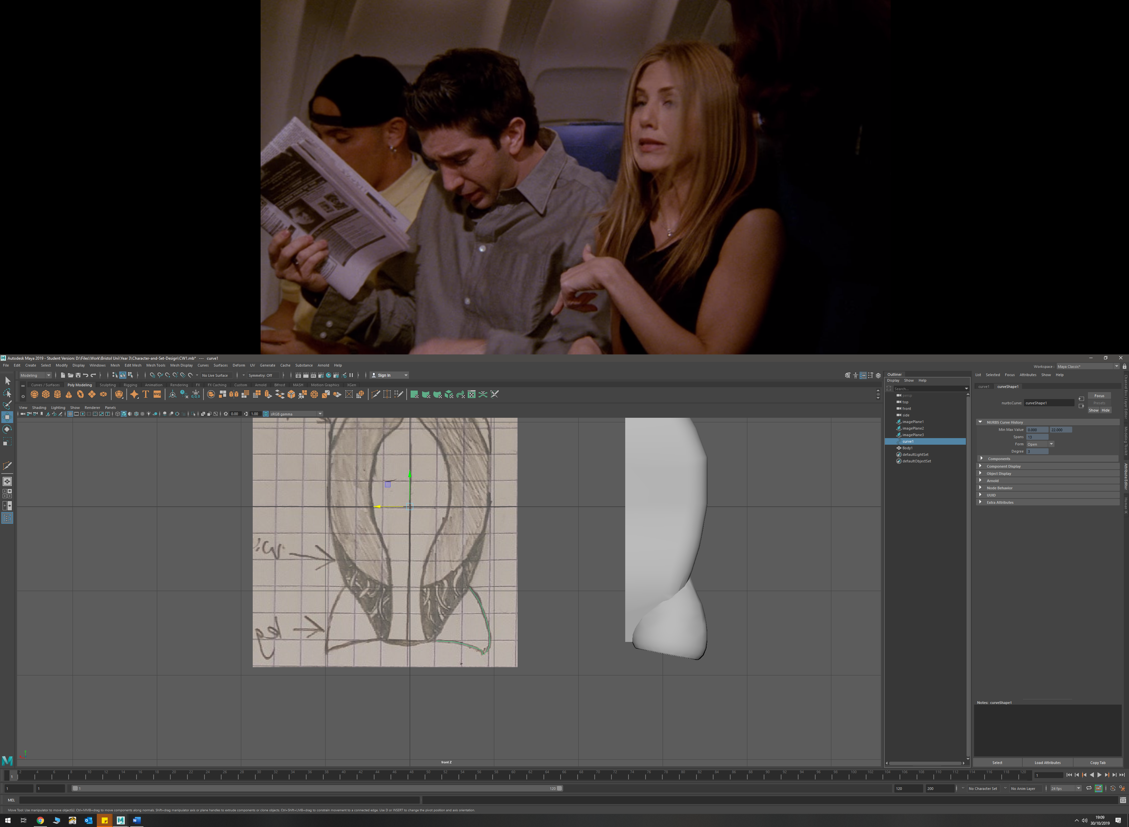

* Used revolve tool in order to create a polygon cone of the correct shape, and used reverse so polygonal mesh was the correct way around

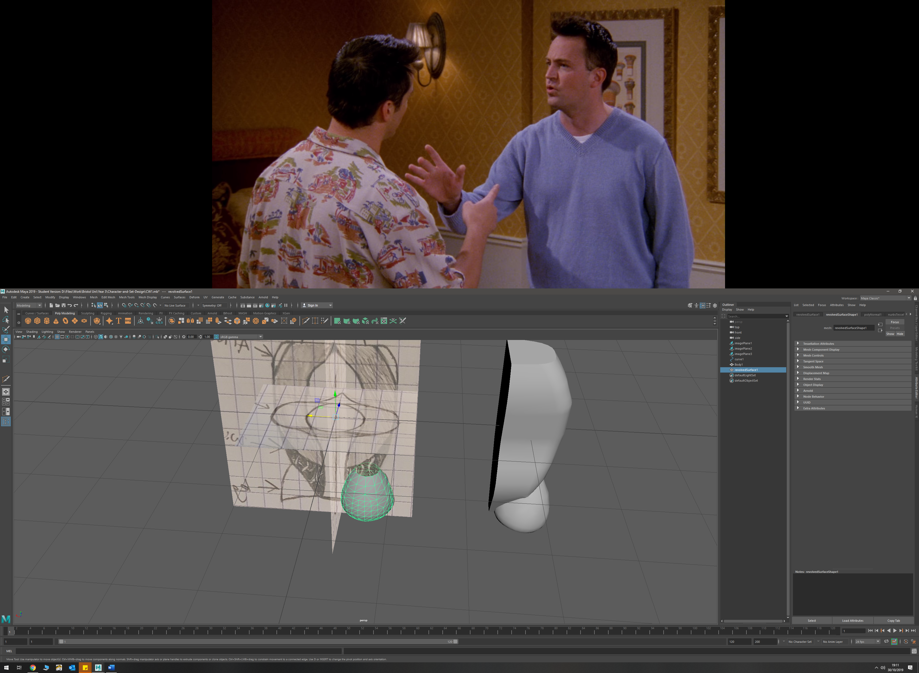

* Extruded edges on top of cone to make correct shape, and a binomial in order to merge the leg mount and body

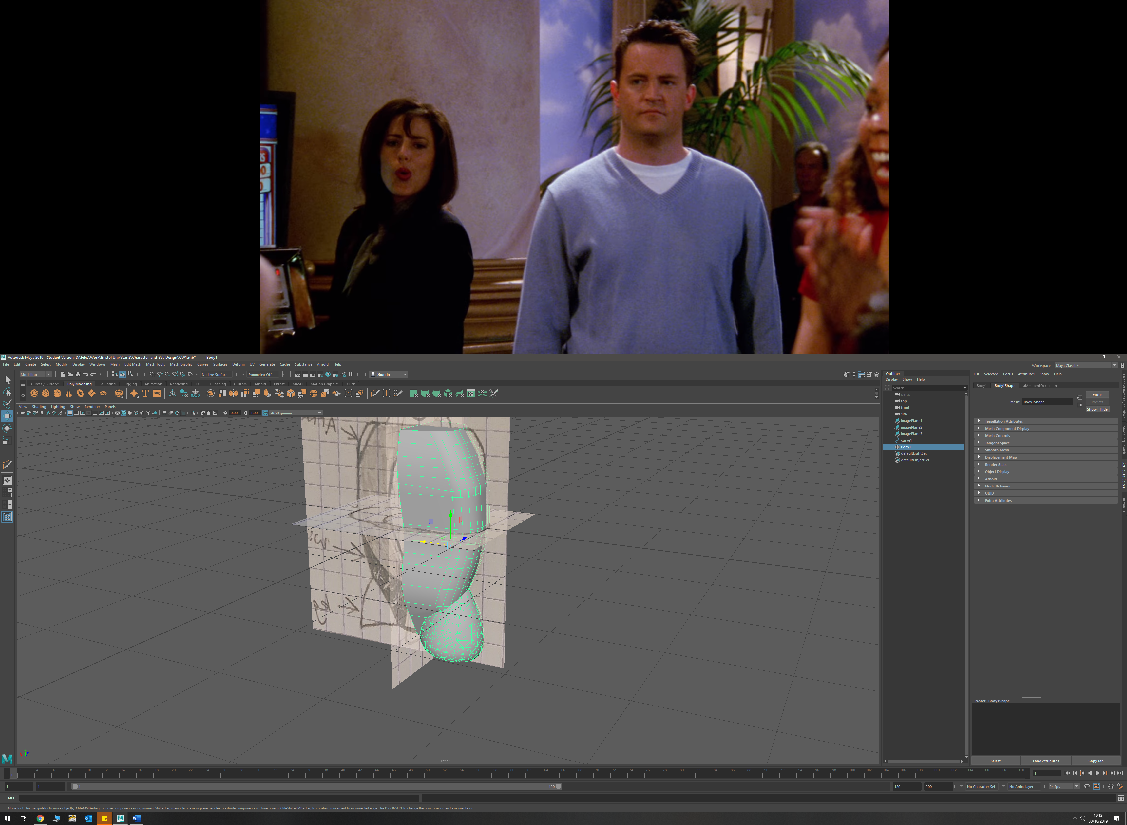

* To make shoulder plates, extruded faces, then merged edges using target weld tool to create smooth transition

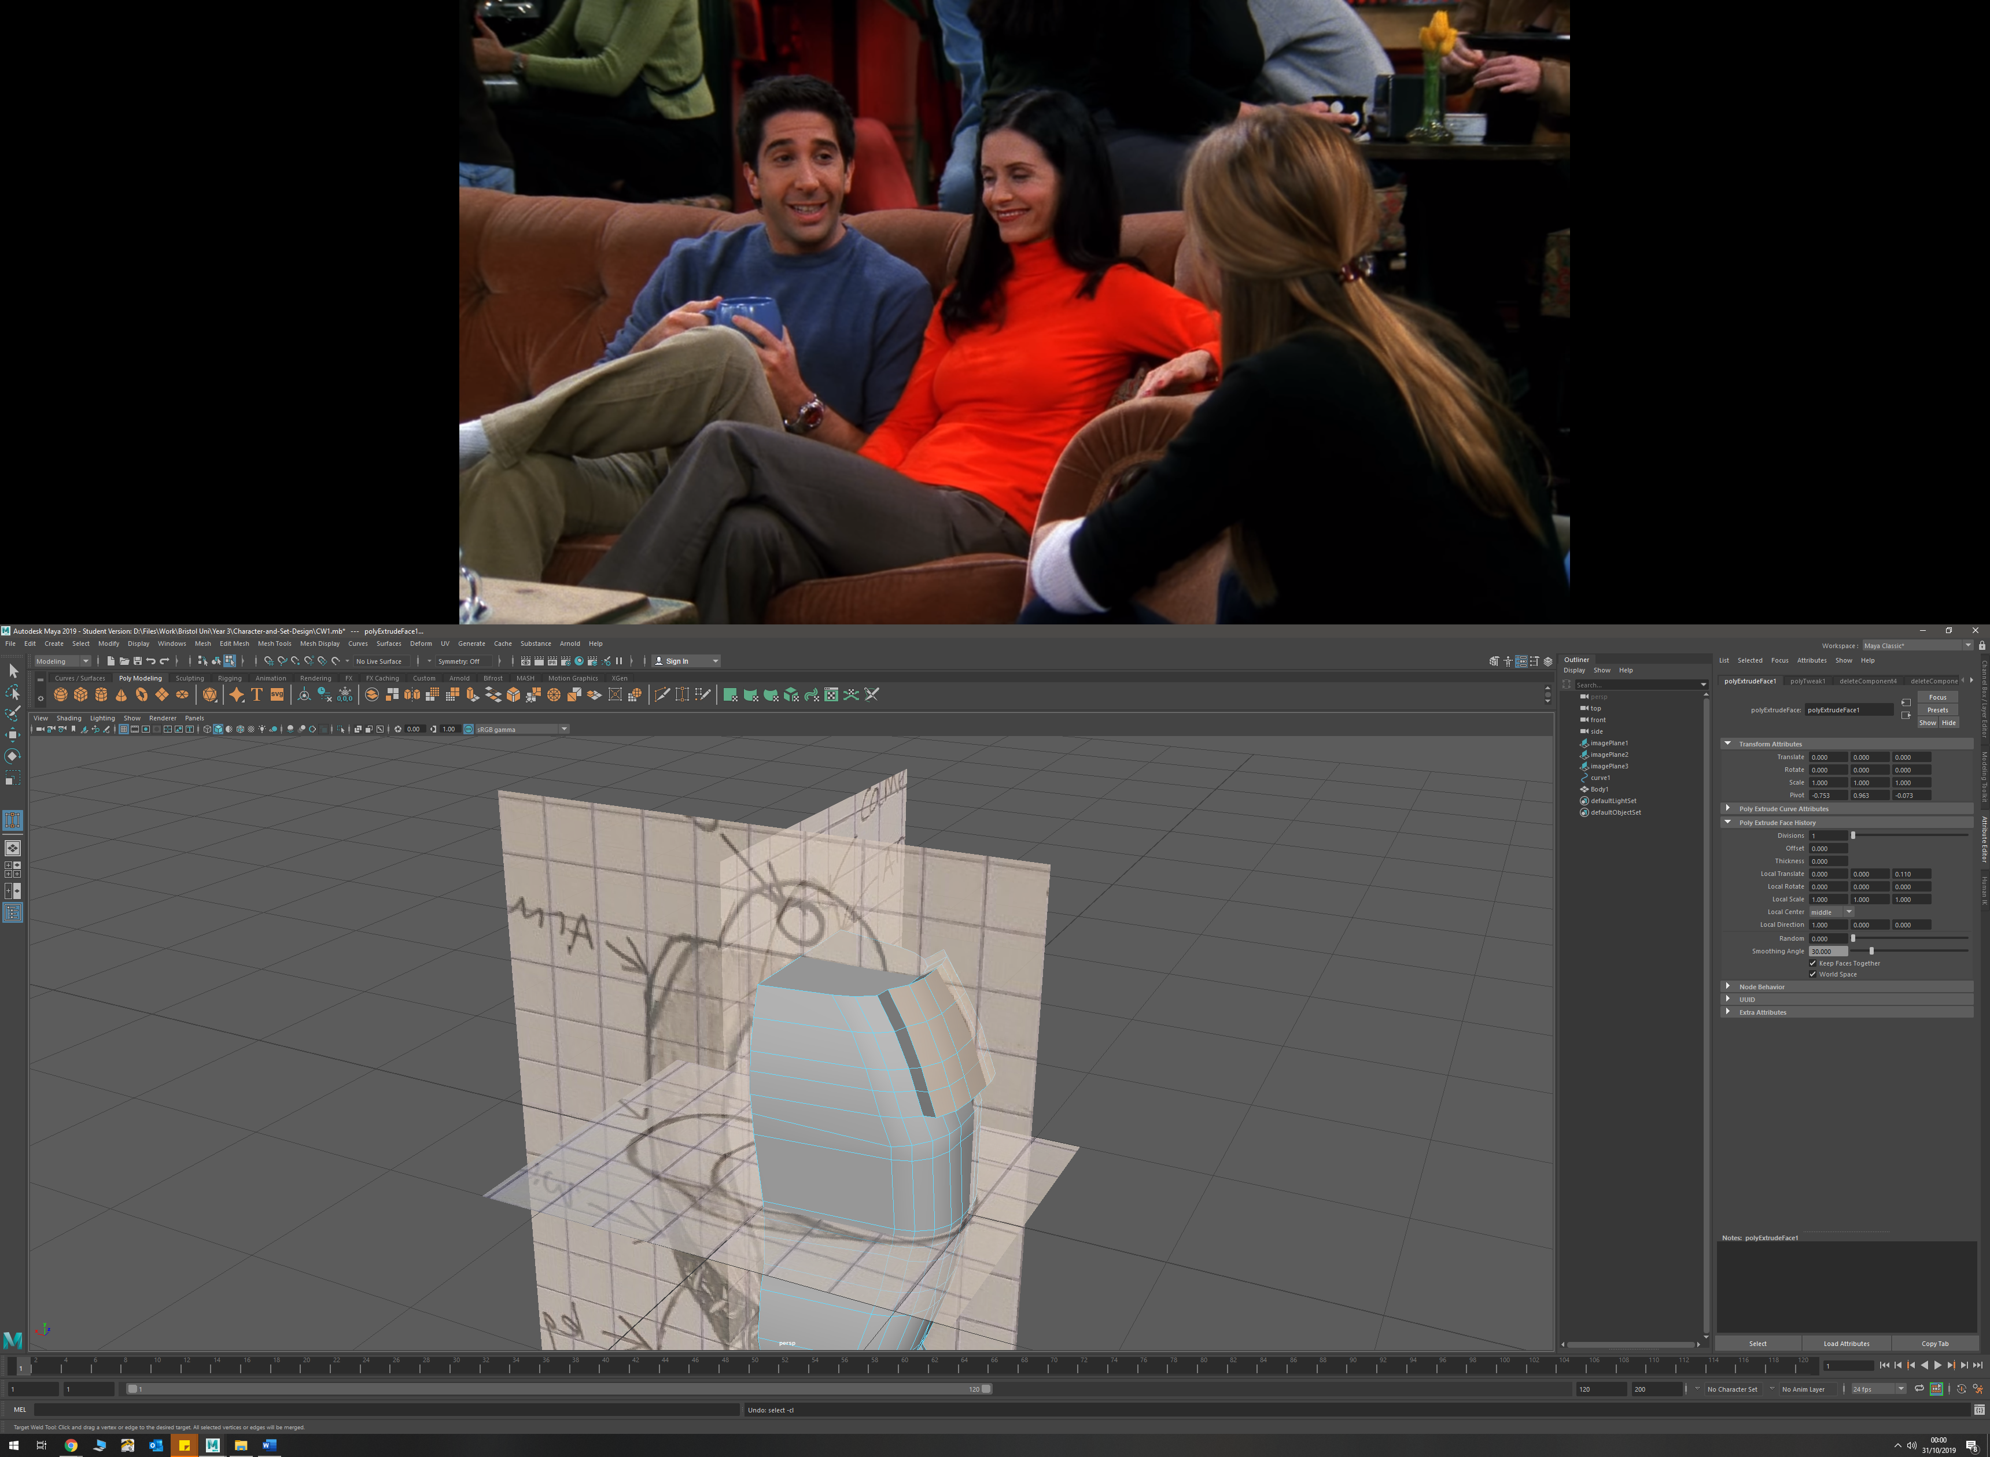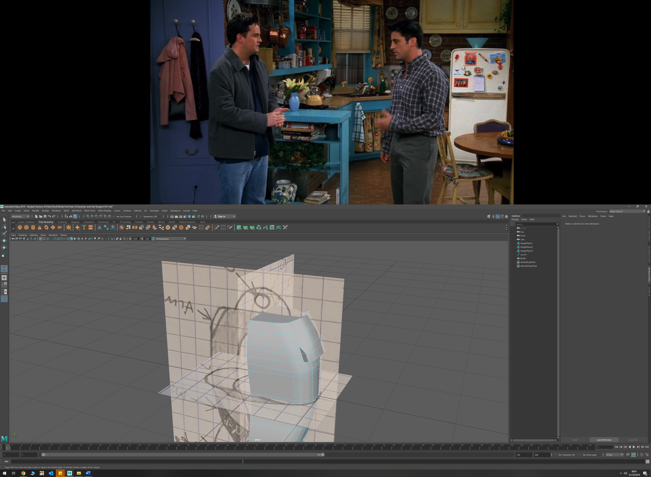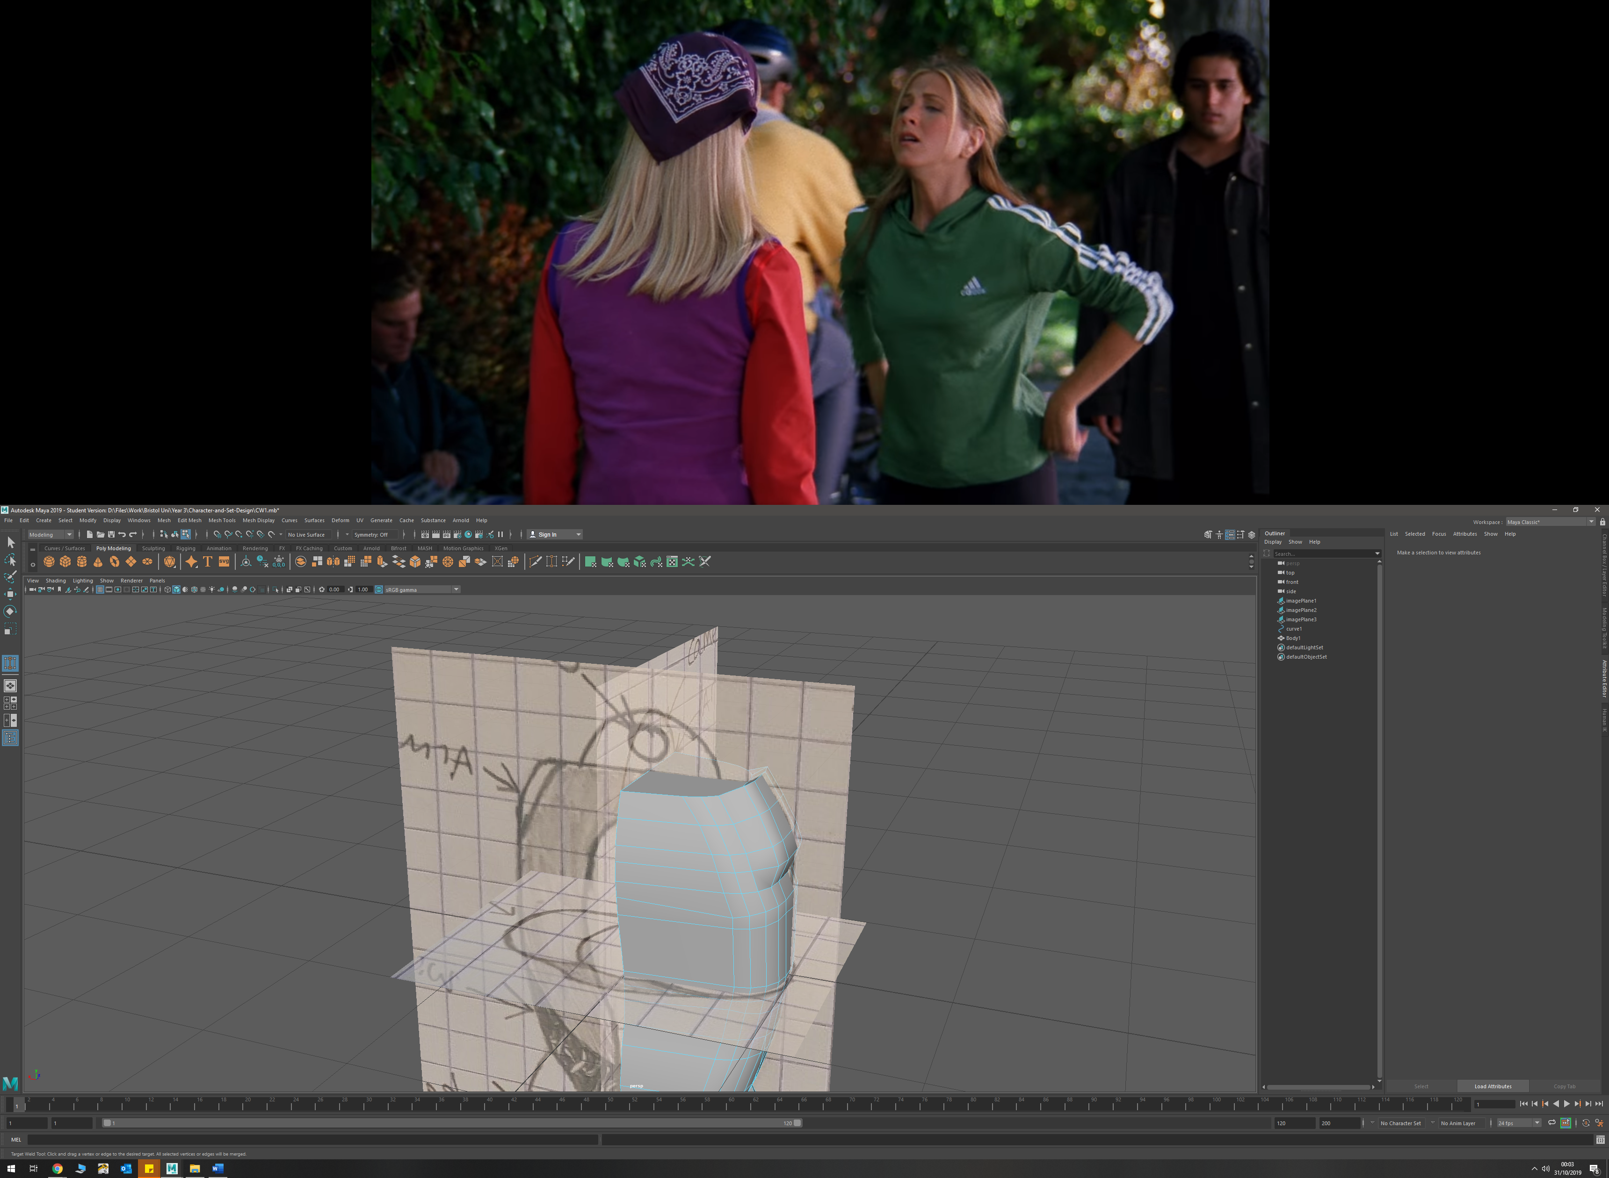

* To create the full body, I used the mirror tool and rotated until as full mesh was created

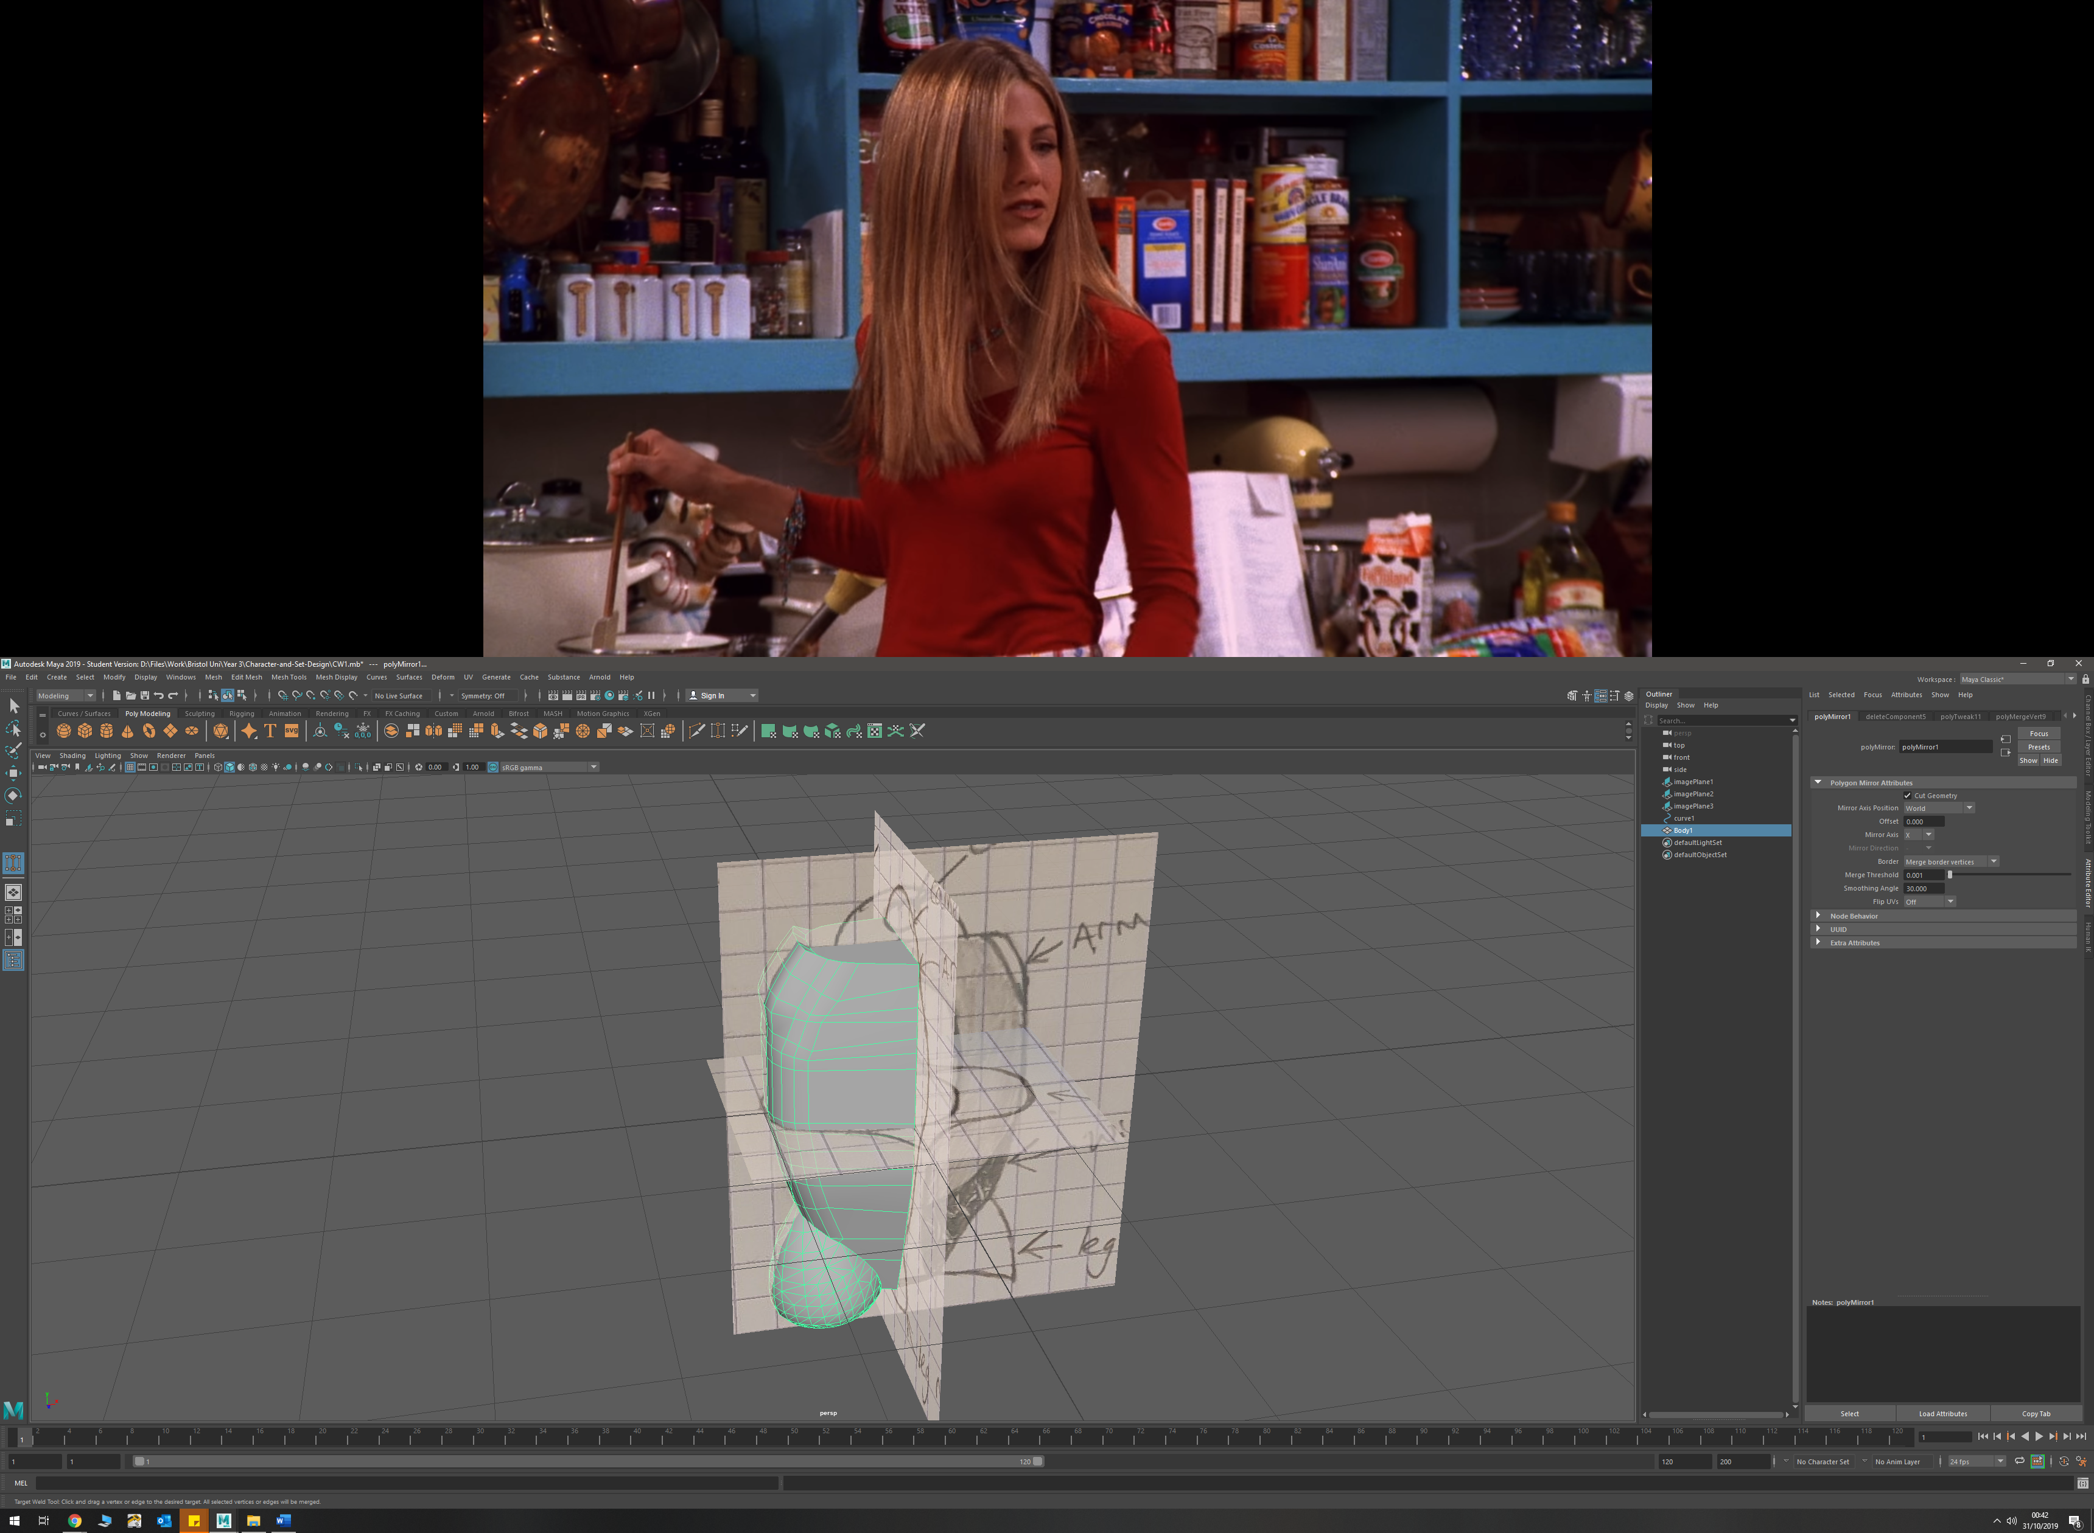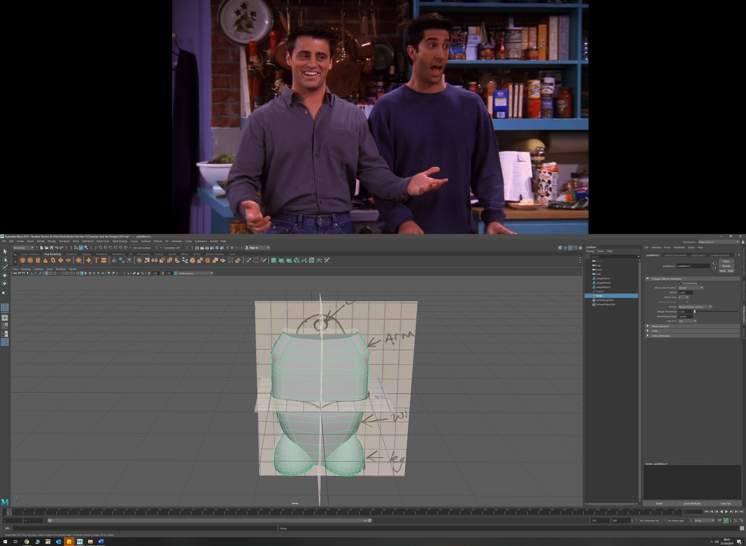

* Body detail was added by selecting faces and extruding them inwards. This will allow me to add inner wiring and cooling vent details once rendered.

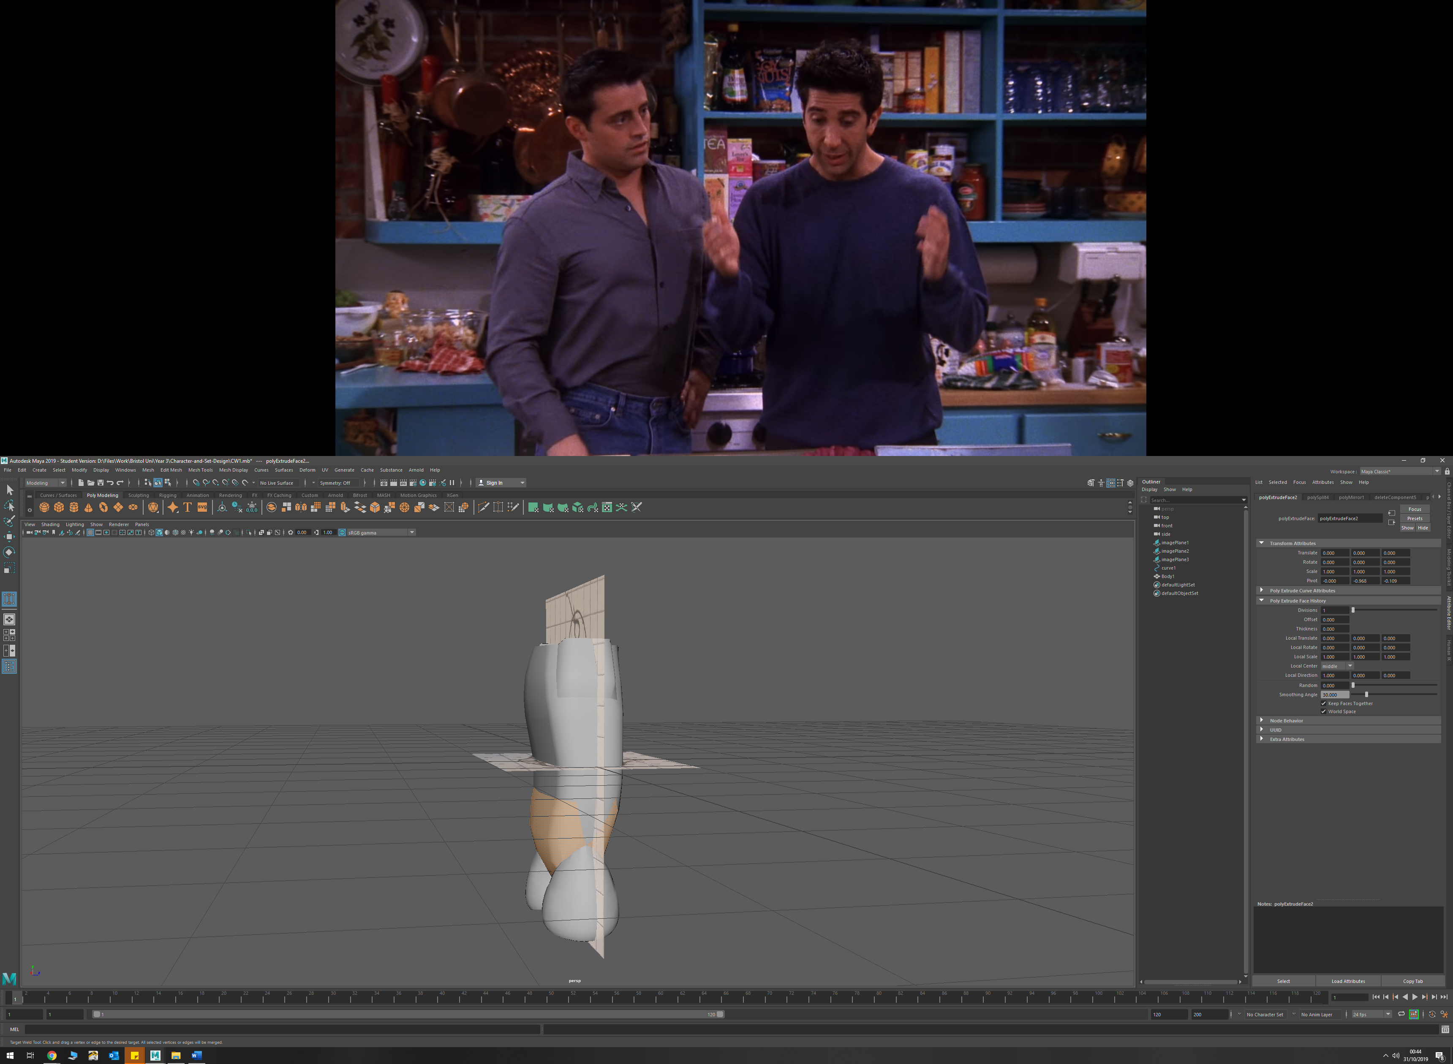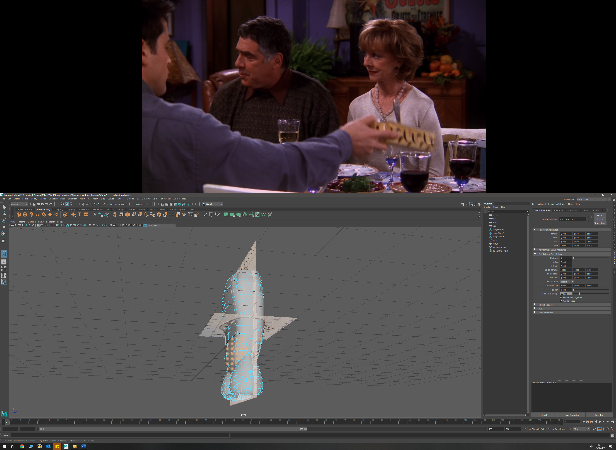

* Created the aerodynamic fin by adding edges to the front of the torso, then selecting faces and extruding them. I then drew a curve to match my sketches of how I wanted the fin to look like from the front, and the side. I then moved vertices to match these curve shapes and create the fin. I also used the target weld tool in order to create the angles I wanted in different sections.

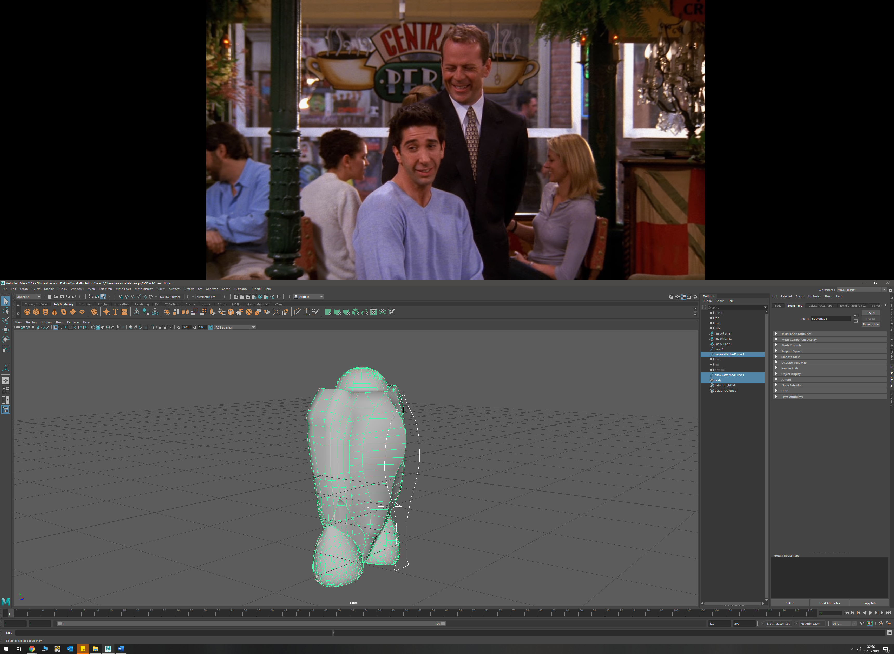

* Used the circularise tool twice, with increased divisions in order to create the camera on the head/dome. I then extruded the outer loop outwards, and the inner circle inwards to create the depth I required

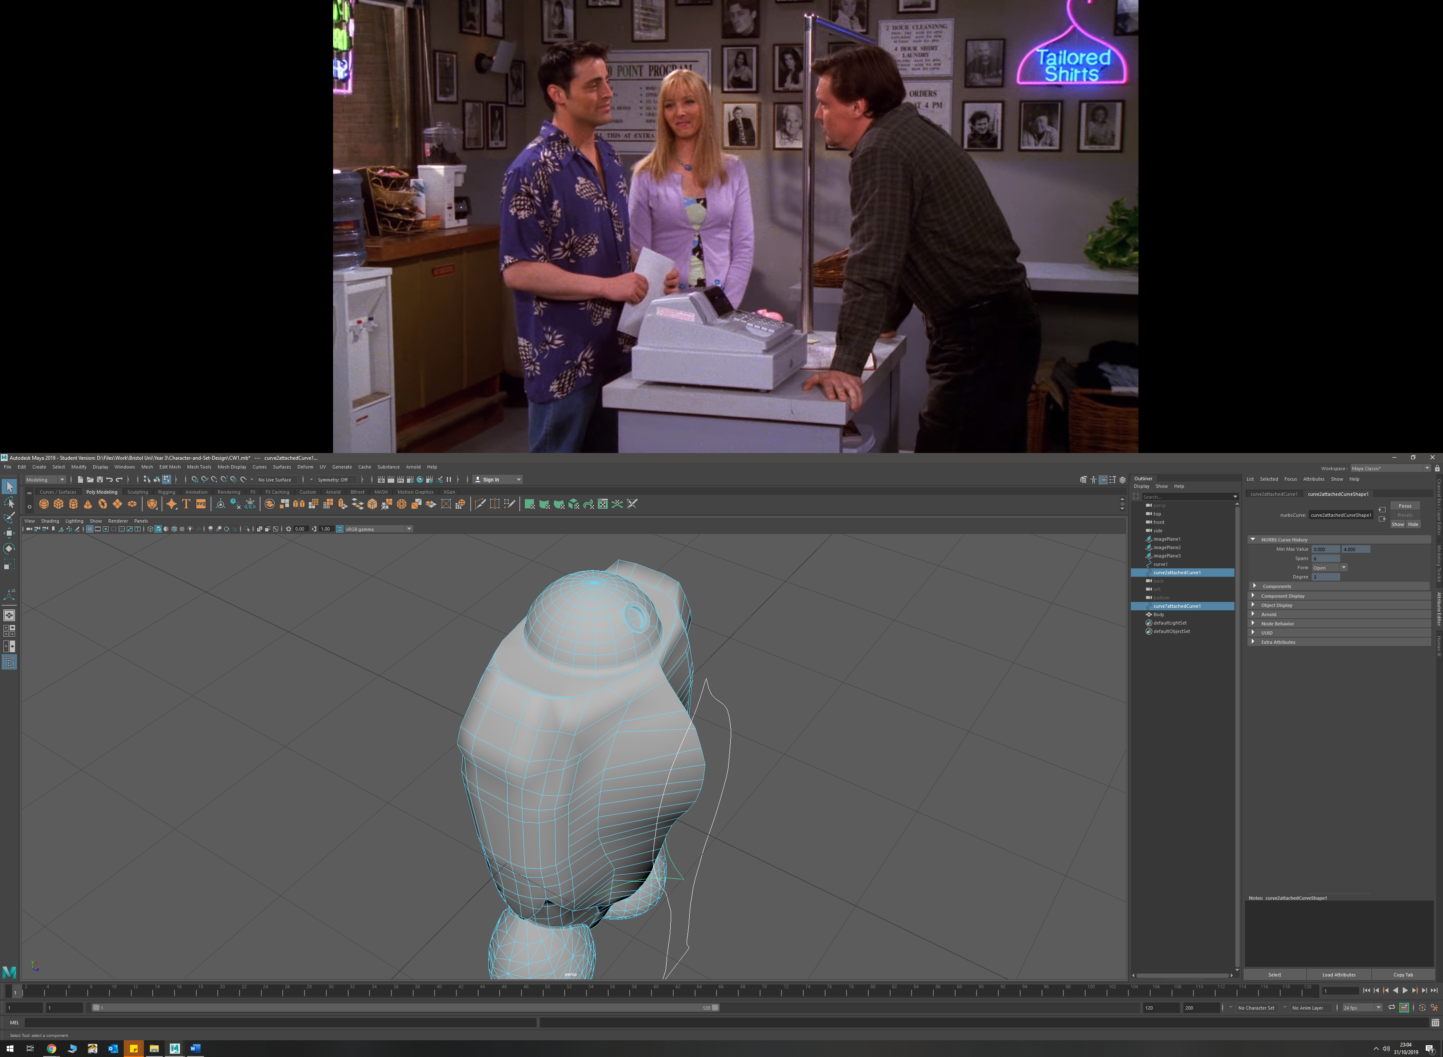

* To create pipe detains on torso, I used a NURBS prefab circle, and drew a EP curve, then extruded a tube by selecting the two. I changed the extrude settings in order to get a rotation in the tube.

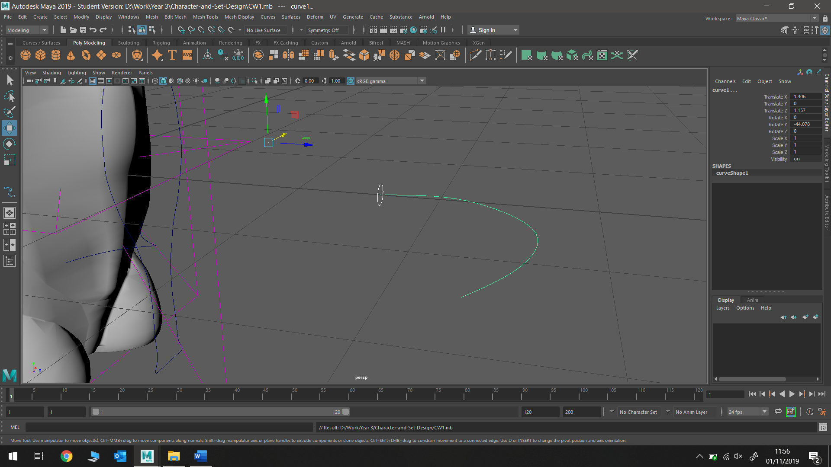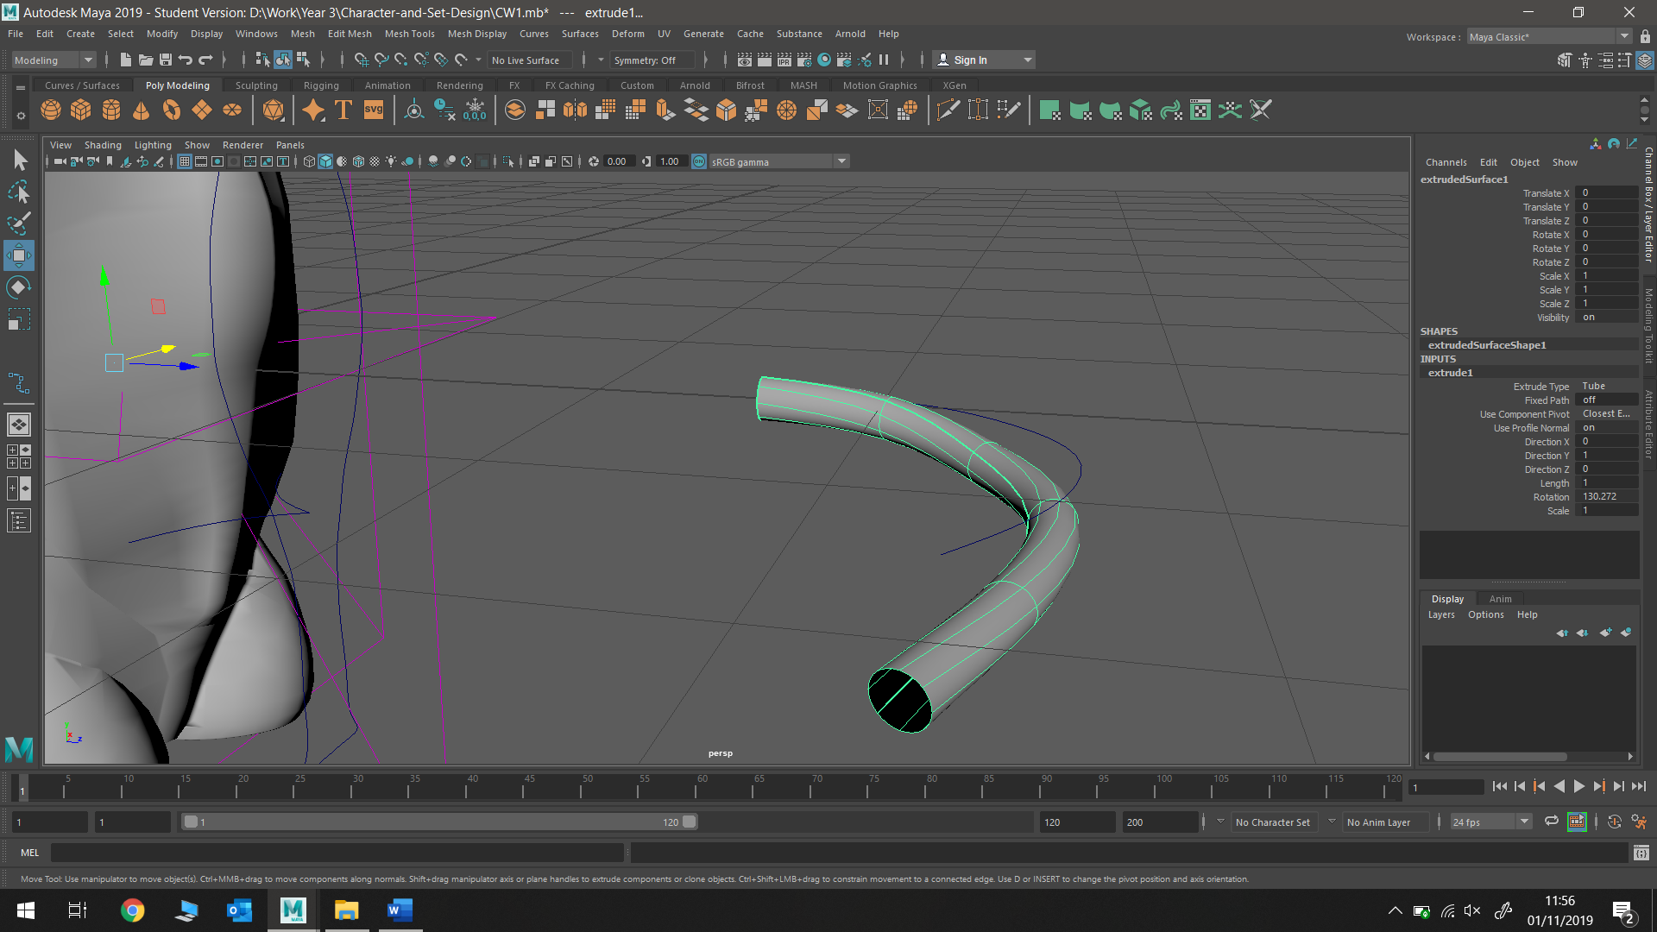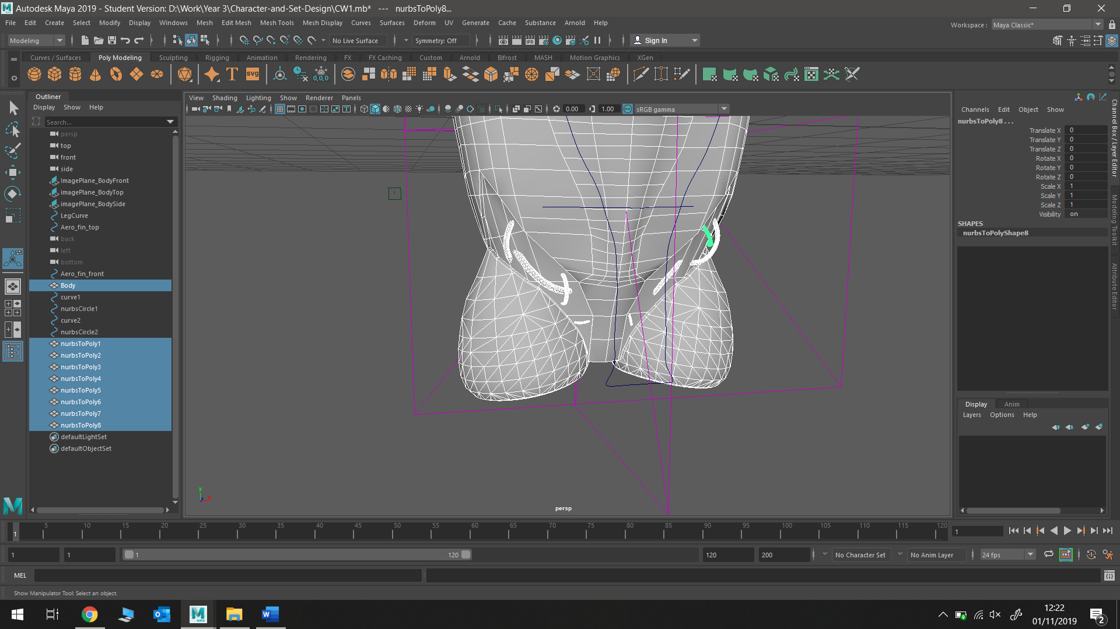

This process was repeated several times to get different tube shapes, thicknesses and paths

* Badminton racket head was made by tracing round an image of the racket with an EP curve, then extruding a NURBS circle along this path. The polygon was then duplicated, and a Boolean was used to join the two halves together.

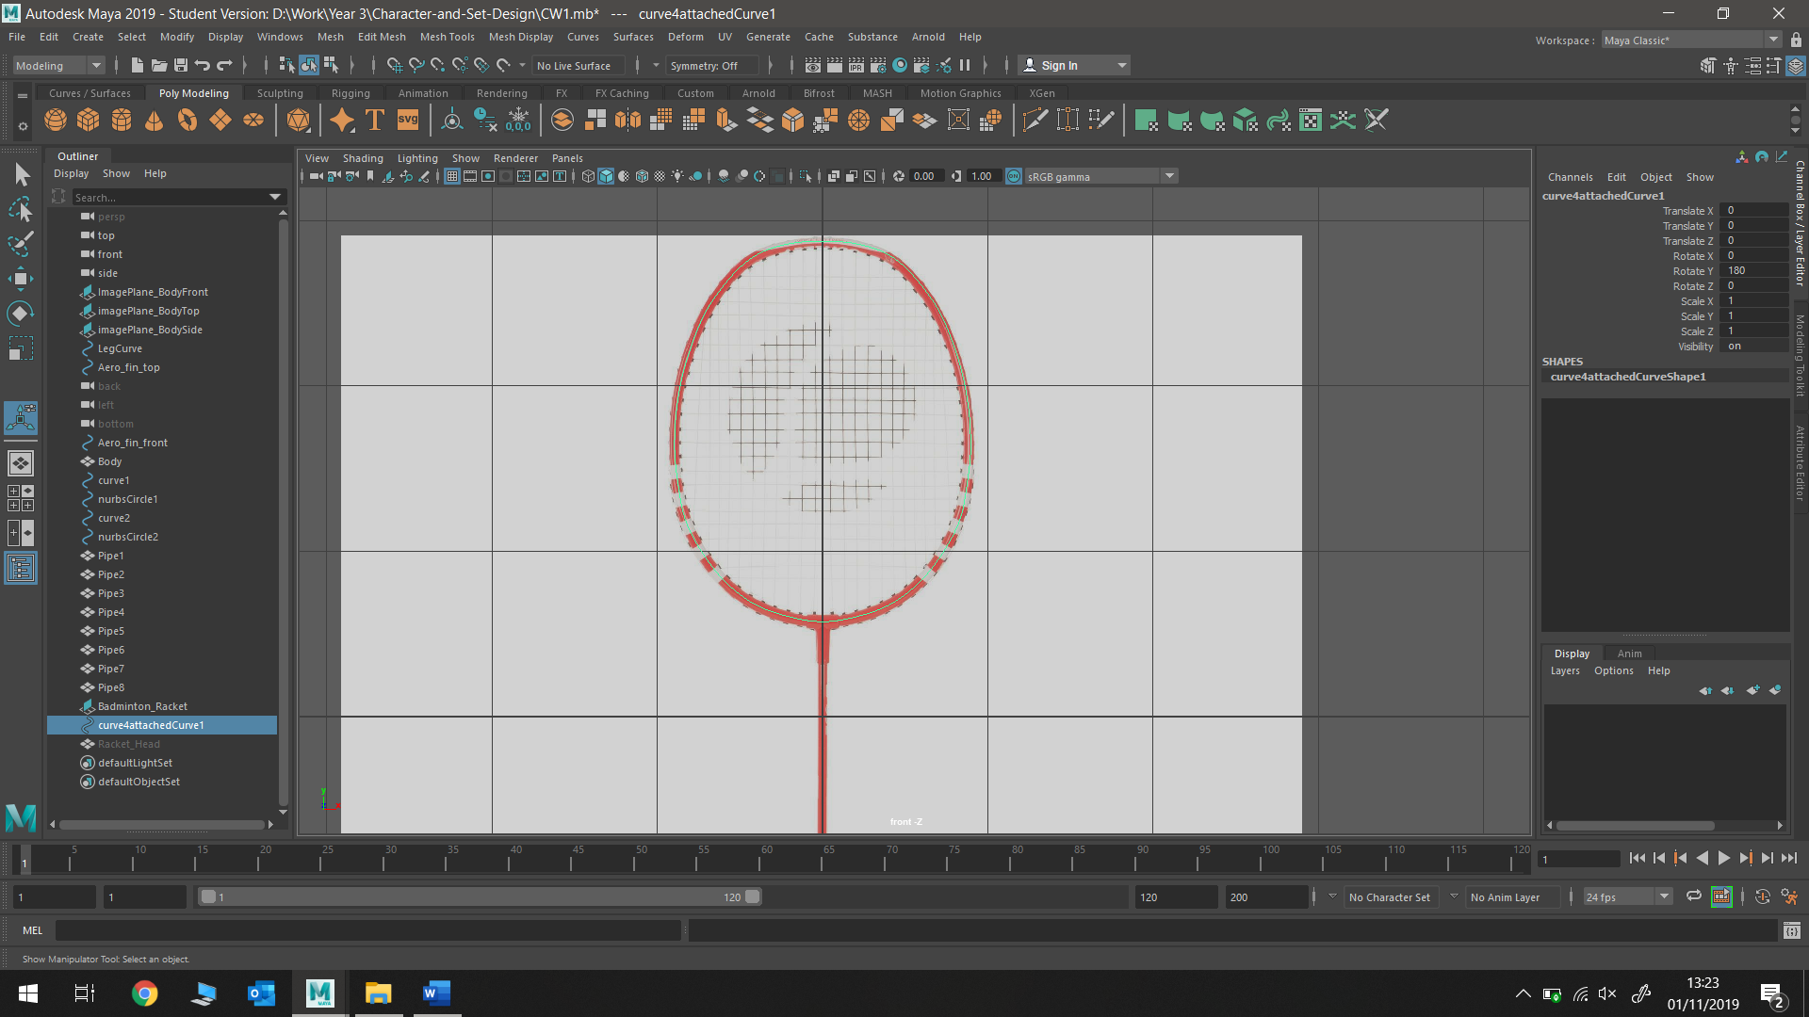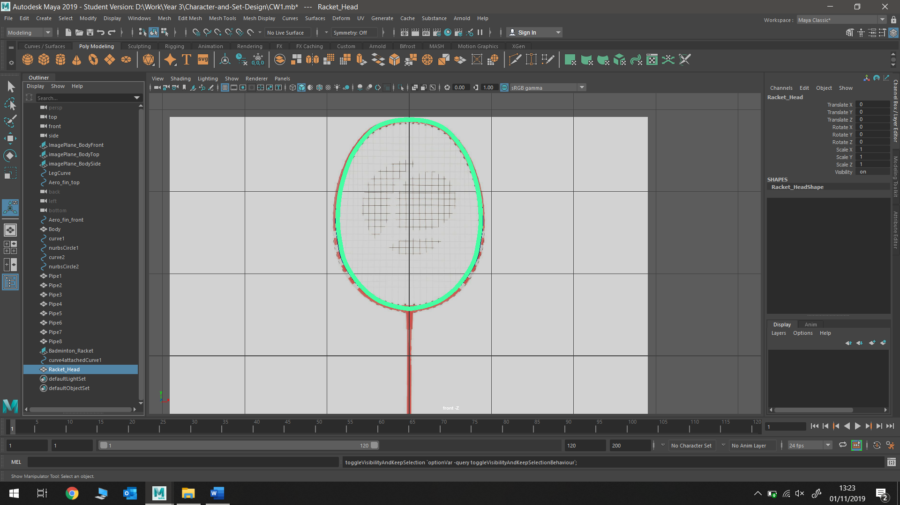

* The rest of the racket was constructed using polygon cylinders that I manipulated to fit the correct shaped of the racket handle; extruding faces and altering face size

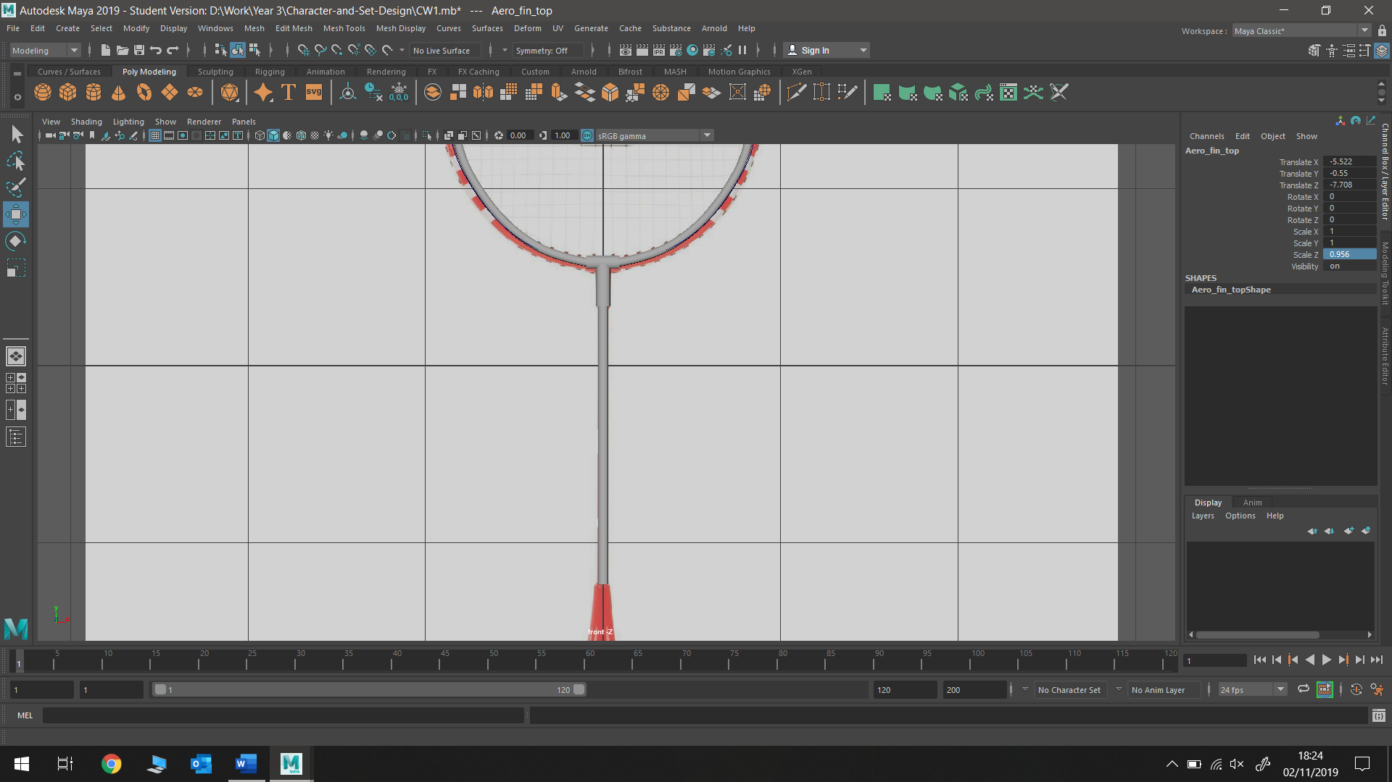 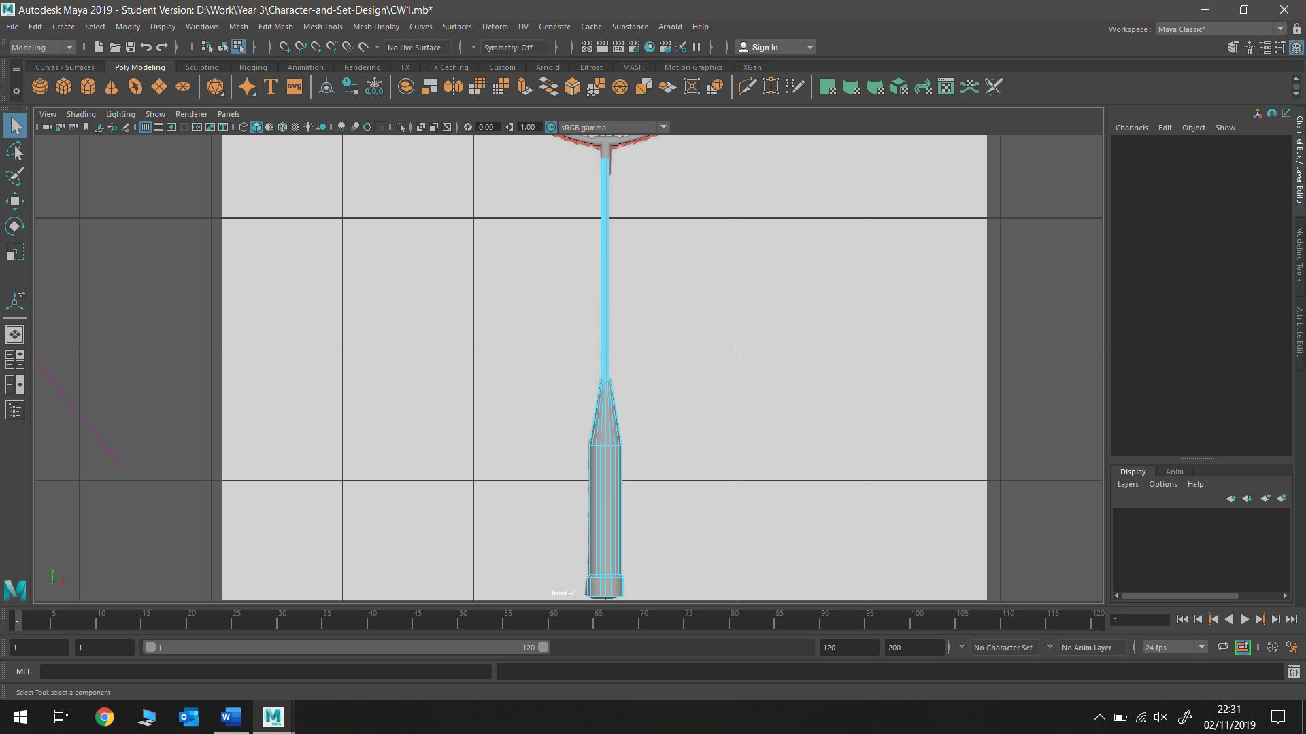

* Badminton racket mesh was created by duplicating a polygon cylinder multiple times to fit frame

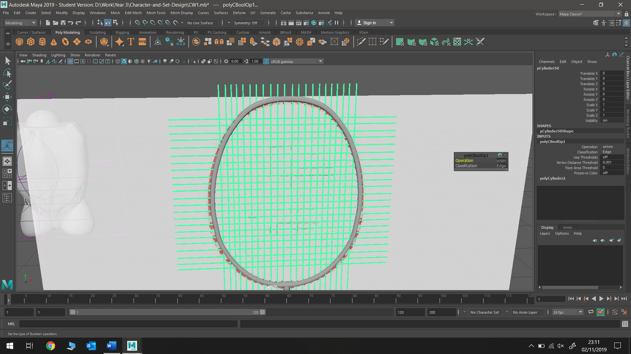

Used a duplicated racket hoop (made larger) to apply Boolean to mesh in order to cut off points of mesh not inside hoop

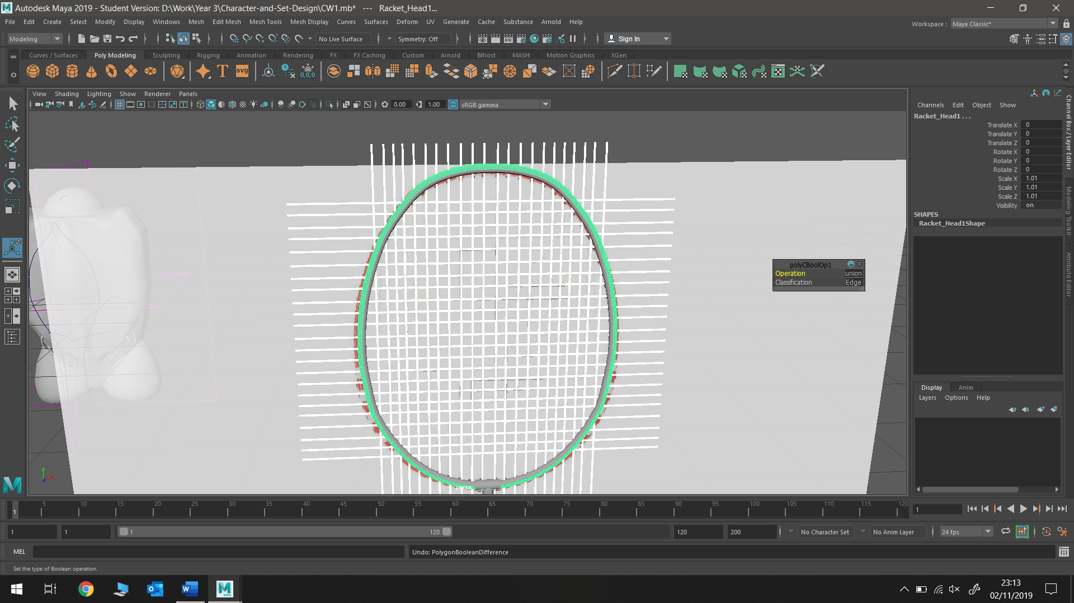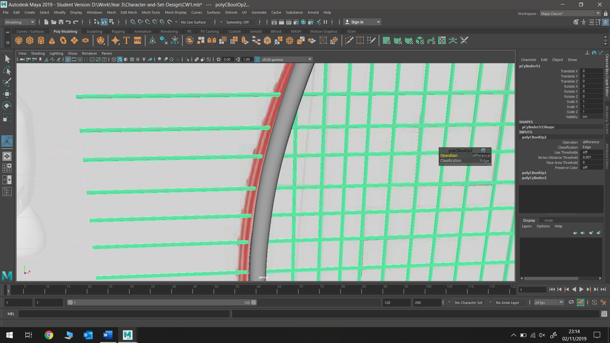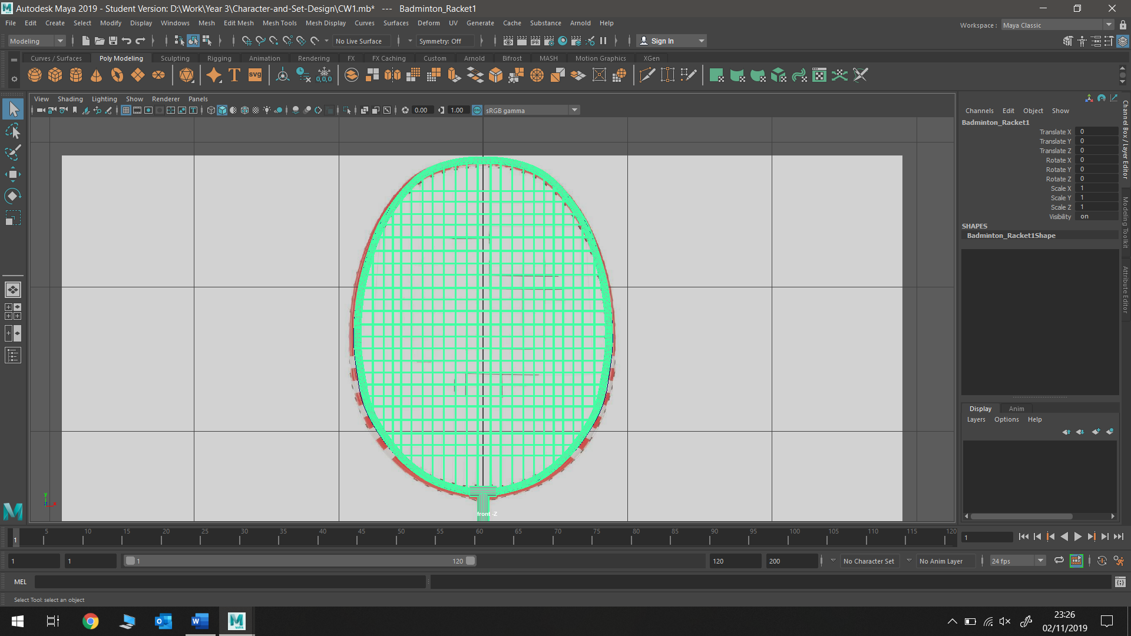

Used separate in order to separate the wanted and unwanted sections of the mesh, and then simply deleted the unwanted(outside the hoop) part of the mesh

**Process and Discussion**

2-3 pages

**Appendix**

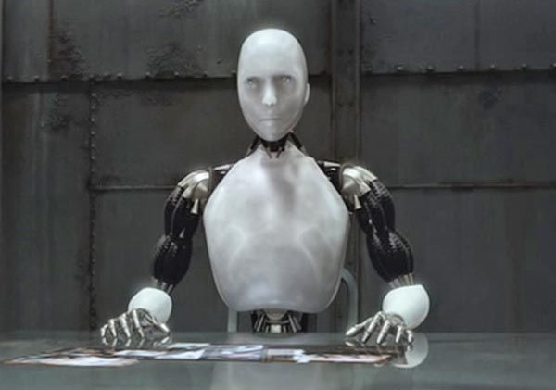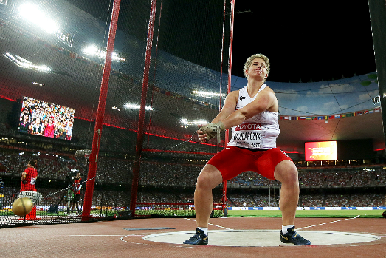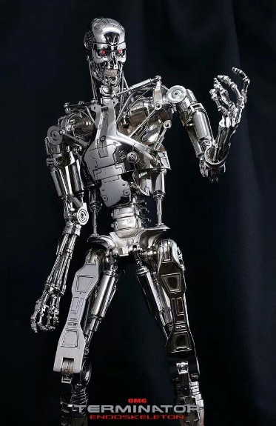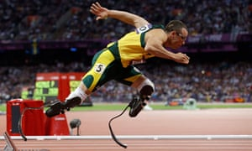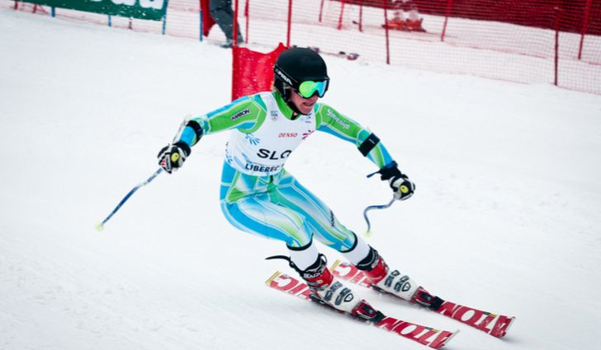**Style Sheet and Visual References**

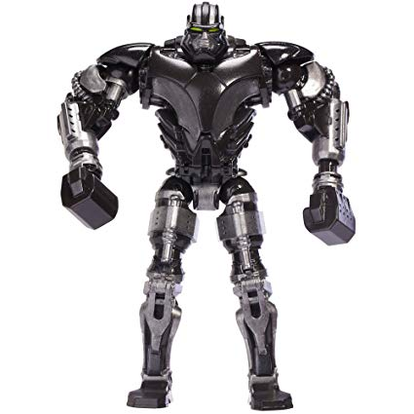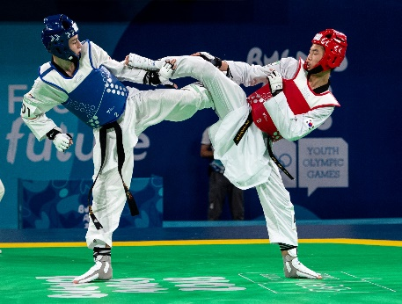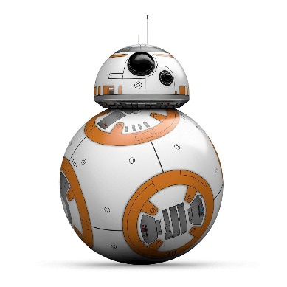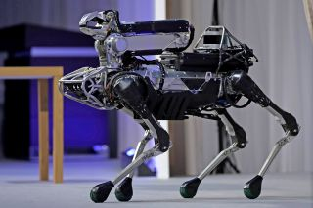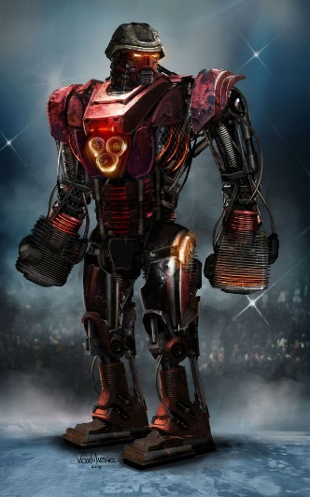

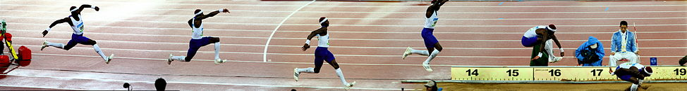

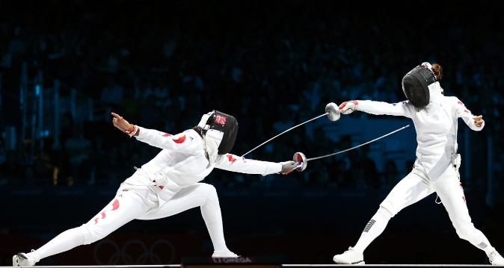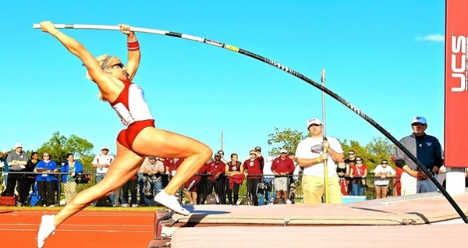

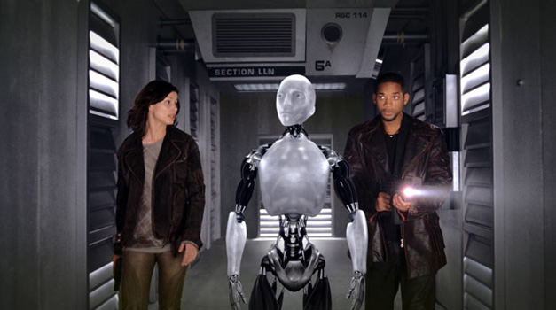

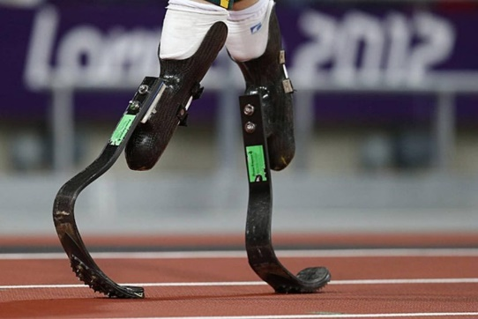

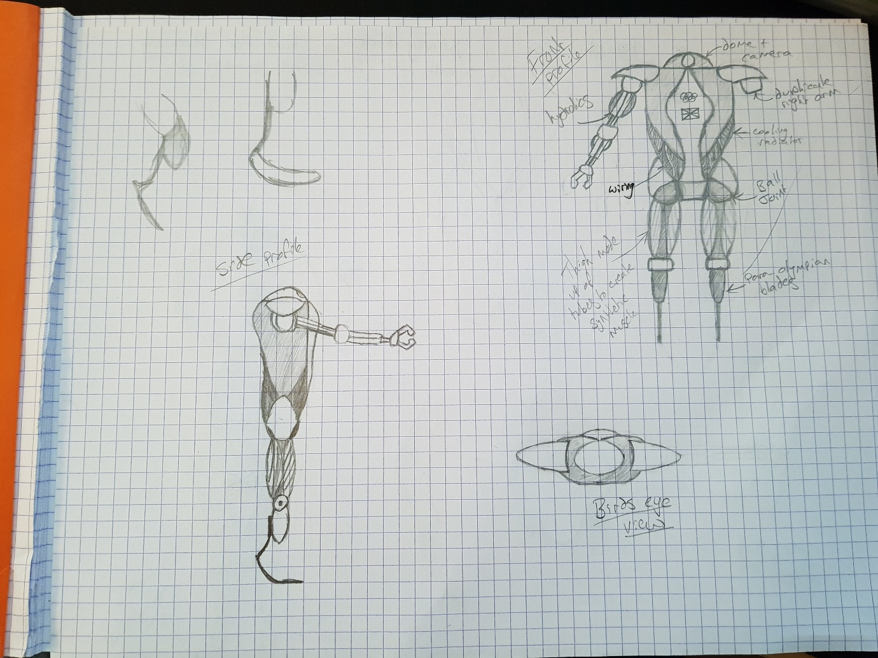**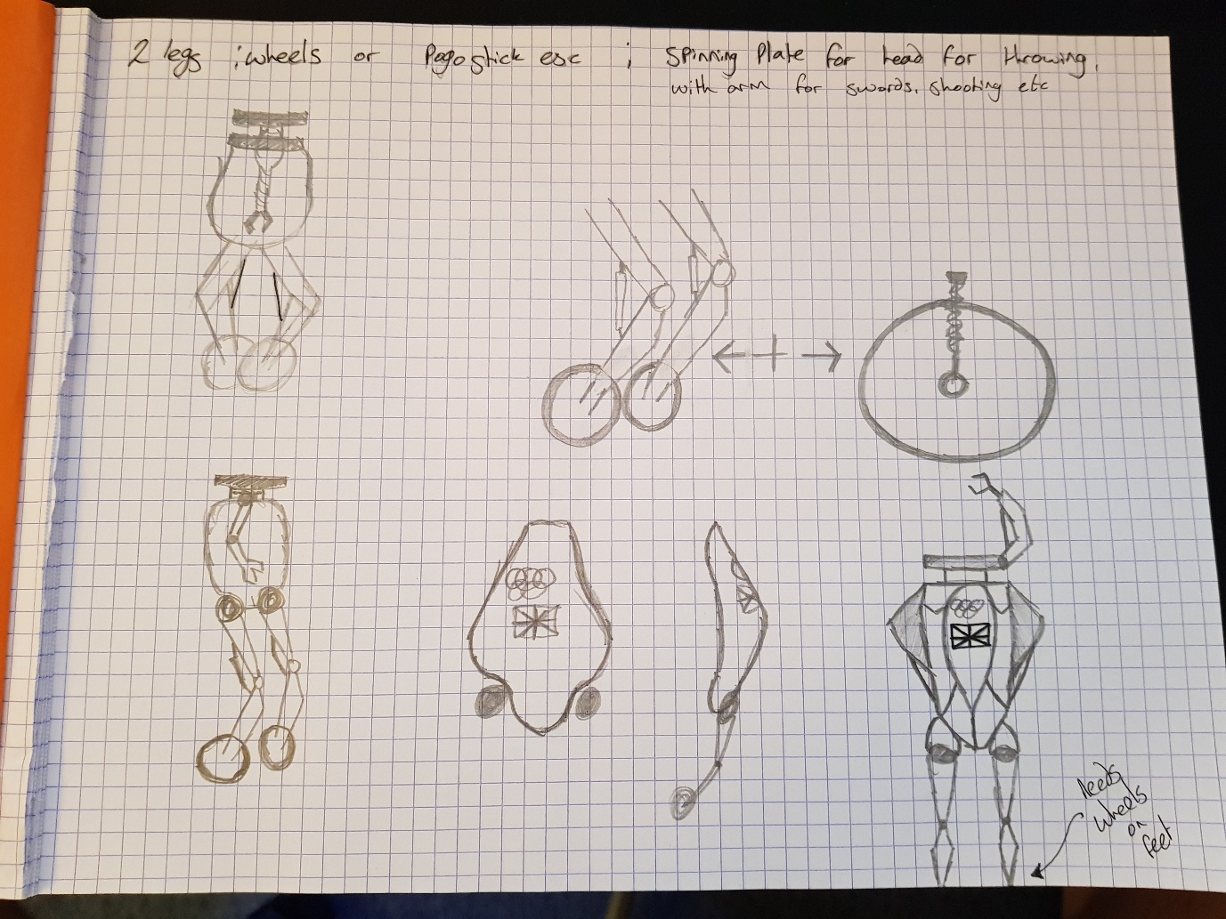Development Drawings**

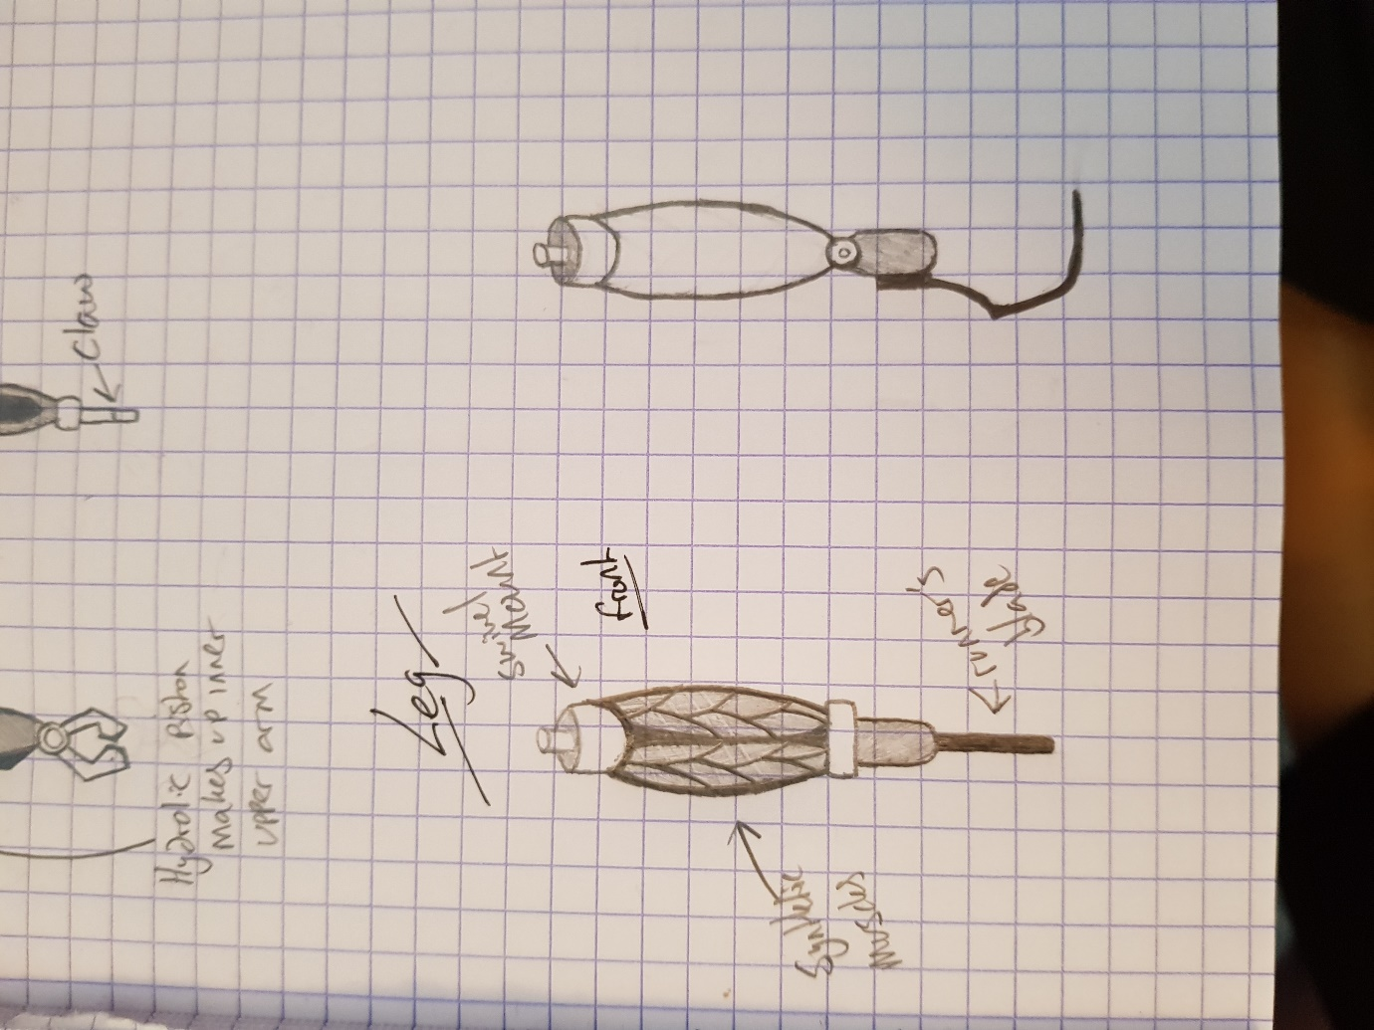**Sketches and Blueprints**

